How to Configure IIS 7 in Windows Server 2008
Follow the Following Steps:

Step 1:
First Open Control Panel, which will display the following Window
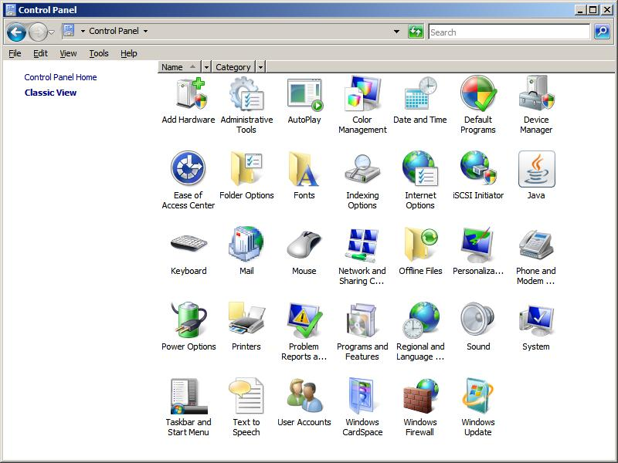

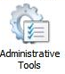
Click Administrative Tools , which open the following window
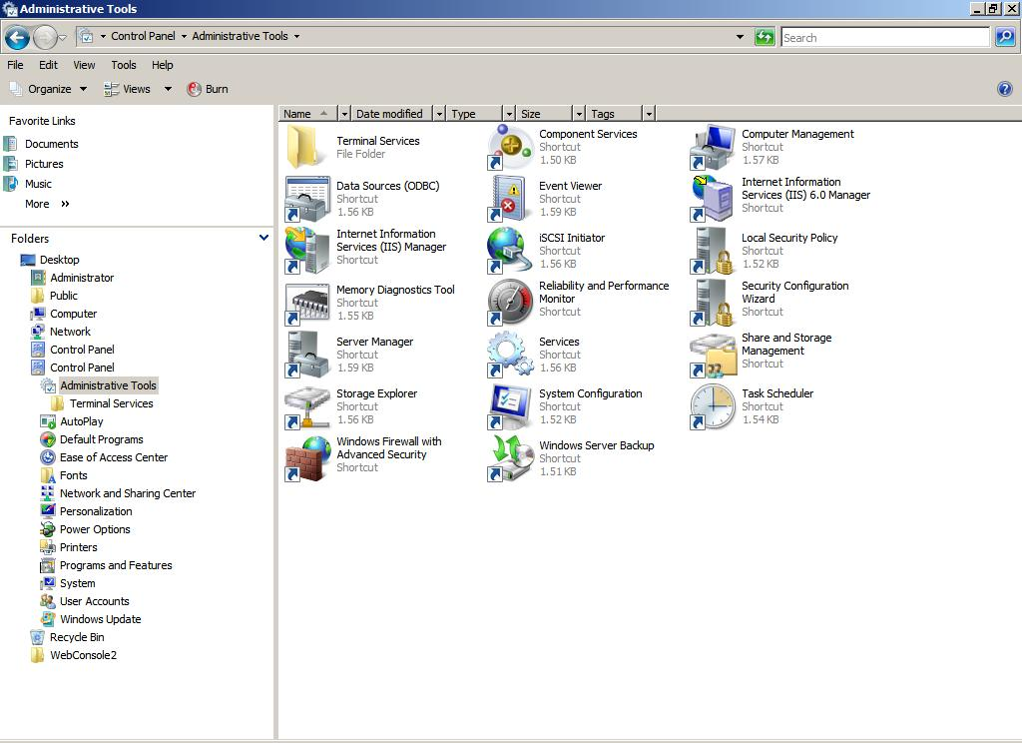
Step 2:
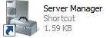
DblClick Server Manager icon to open the following window

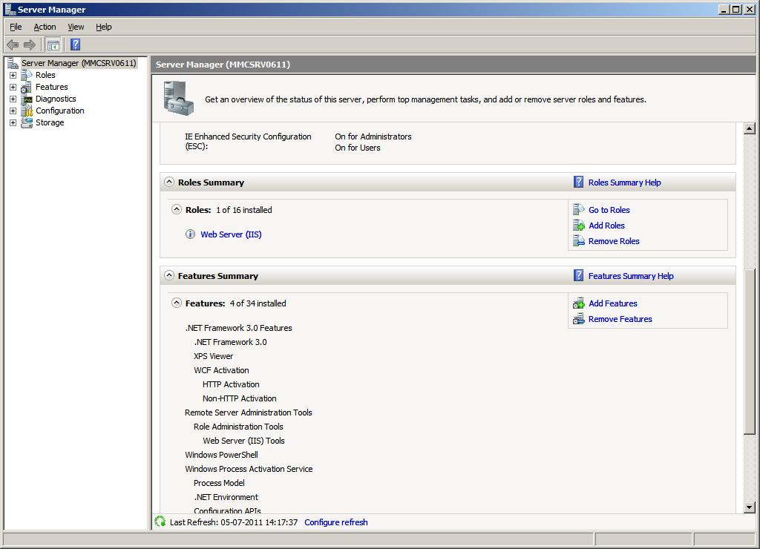
Now Click on Web Server (IIS)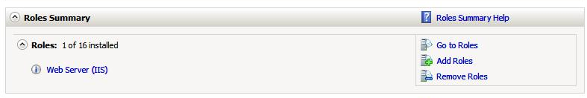

It will open a window like this
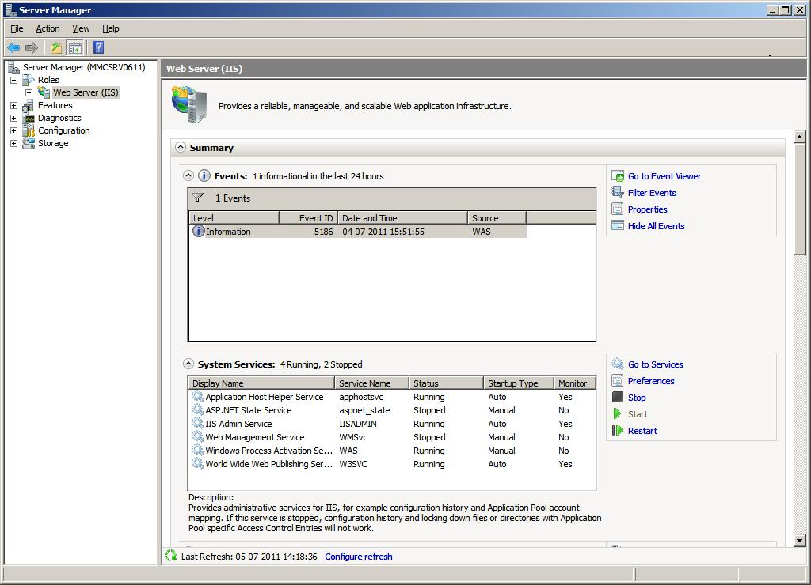

Step 3:
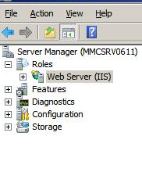
Now Right Click on Web Server (IIS).

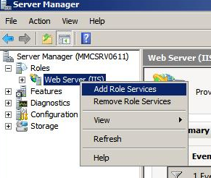

This will open a menu like this one

Now Select Add Role Services
Now a new window spans like this
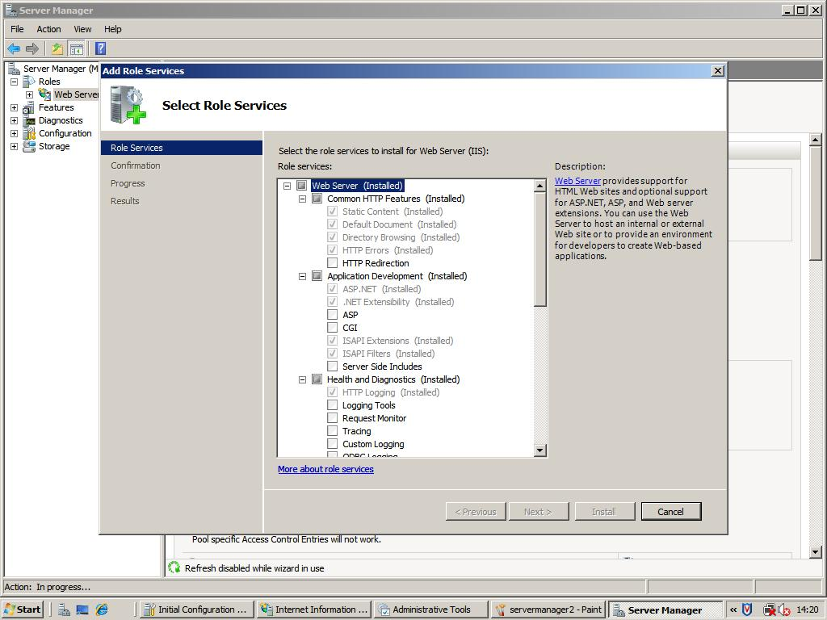
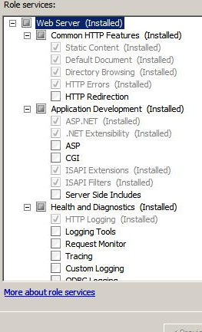
If You are doing first time IIS Installation then
All the Options will appear unselected. Now select the required Check Box
For more detail description about the options please refer to
The right hand side corner of the screen ,whenever you are
Selecting any option it will give you a more clear idea about
What you are selecting.

After selecting the required Option Click the install Button .
It will install IIS7 for You.
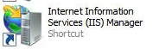
An icon will appear in control panel.

If you are editing/changing your options for your IIS7, then Now Select the required Check Box .
For more detail description about the options please refer to
The right hand side corner of the screen, whenever you are
Selecting any option it will give you a more clear idea about What you are selecting. After selecting the required Option Click the install Button.

Good Luck .

